1905387

CHAUDHARY HAMDAN

WT LAB ASSIGNMENT 3

Date : 22-01-2021

1. Program to print your name, roll no, section and branch in separate lines.

Code :

class Lab3Q1 {

public static void main(String args[]) {

System.out.println("Name : Chaudhary Hamdan");

System.out.println("Roll number : 1905387");

System.out.println("Sectuion : CS-6");

System.out.println("Branch : CSE");

}

}

Output :

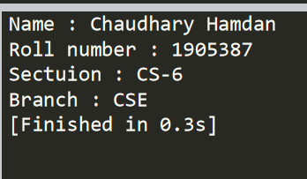

2. Program to print the corresponding grade for the given mark using if..else statement in Java

Code :

class Lab3Q2 {

public static void main(String args[]) {

int m = 89;

char grade = 'F';

if (m >= 90)

grade = 'O';

else if (m >= 80)

grade = 'E';

else if (m >= 70)

grade = 'A';

else if (m >= 60)

grade = 'B';

else if (m >= 50)

grade = 'C';

else if (m >= 40)

grade = 'D';

System.out.println("Grade : " + grade);

}

}

Output :

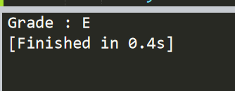

3. Program to print the corresponding week day for the given day no. of the current month using switch..case statement in Java

Code :

class Lab3Q3 {

public static void main(String args[]) {

int n = 3;

String day = "";

switch (n) {

case 1:

day = "Monday";

break;

case 2:

day = "Tuesday";

break;

case 3:

day = "Wednesday";

break;

case 4:

day = "Thursday";

break;

case 5:

day = "Friday";

break;

case 6:

day = "Saturday";

break;

case 7:

day = "Sunday";

break;

default :

day = "Wrong Choice";

}

System.out.println("Output : " + day);

}

}

Output :

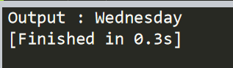

4. Program to check a user entered number is palindrome or not.

Code :

class Lab3Q4 {

public static void main(String args[]) {

int n = 12321;

int m = n;

int ans = 0;

while (m != 0) {

ans = ans \* 10 + m % 10;

m /= 10;

}

if (ans == n)

System.out.println("Palindrome");

else

System.out.println("Not Palindrome");

}

}

Output :

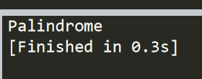

5. Write a program in Java to take first name and last name from user and print both in one line as last name followed by first name.

Code :

import java.util.Scanner;

class Lab3Q5 {

public static void main(String args[]) {

Scanner sc = new Scanner(System.in);

System.out.println("Enter first name and the last name :-");

String first = sc.next();

String last = sc.next();

System.out.println(first + " " + last);

}

}

Output :

